**Venn Diagram Project: User Manual**

Group 4

This Prototype Manual was prepared as a requirement for York University’s Software Development Project Course, EECS 2311.

_________________________

**Nabi Khalid, 216441677**

In charge of documentation

_________________________

**Andrew Hocking, 215752835**

Technical Leader and Repository Expert

_____________________

**Anika Prova, 216474306**

In charge of testing

_________________________

**Nourin Abd El Hadi, 216107021**

Project Manager and Front-End Developer

# Version History

|  |  |  |  |  |
| --- | --- | --- | --- | --- |
| **Revision** | **Date** | **Author(s)** | **Section/Pages**  **Affected** | **Remarks** |
| Version 1 | February 9th, 2020 | Nabi Khalid, Nourin Abd El Hadi, Andrew Hocking, Anika Prova | Entire Document | Initial document, Subject to revision |
| Version 2 | February 23rd, 2020 | Nabi Khalid, Nourin Abd El Hadi, Andrew Hocking, Anika Prova | Entire Document | Midterm Submission |
| Version 3 | March 8th, 2020 | Nourin Abd El Hadi, Andrew Hocking, Anika Prova, Nabi Khalid | The User Interface | Major changes to functionality |

# Table of Contents

Version History 3

Table of Contents 4

1. Introduction 5

1.1. Purpose 5

1.2. Scope and Scalability 5

1.3. Getting Started 5

2. Features 7

3. Usage Scenarios 8

4. The User Interface 11

5. Future Work 12

# 

1. Introduction

## 1.1. Purpose

The purpose of the Venn Diagram program is simple, to provide a simple, clean, and concise Venn Diagram application that will surpass the basic Venn Diagram capabilities.

Table 1: Components Completed

|  |  |
| --- | --- |
| **Item** | **Interface/Feature** |
| **1.** | **It allows the user to take a screenshot of the Venn diagram and save the image to their computer.** |
| **2.** | **It allows the user to drag and drop text that they enter to any circle they want.** |
| **3.** | **It allows the user to add customizable titles for the diagram and each circle.** |
| **4.** | **It lets the user save the diagram they created as a .venn file** |
| **5.** | **It allows the user to open a .venn file and continue editing.** |

Table 2: Components to be Developed, see Section 5: Future Work

|  |  |
| --- | --- |
| **Item** | **Interface/Feature** |
| **1.** | **It will be able to automatically check if there is a union.** |
| **2.** | **It will be able to download Venn diagrams as text files.** |
| **3.** | **It will be able to upload a text file and have the contents compared.** |
| **4.** | **It will allow users to upload and compare images.** |

## 1.2. Scope and Scalability

The scope of this project is very large and broad, with lots of room for improvement. Some examples of the potential scale of this project include the addition of more than two sets in a Venn diagram, ability to save and load Venn diagrams, and the ability to add more than just text into a Venn diagram. These are only a few examples of the scope of the project; the Venn Diagram project is by no means limited to these. See Section 5: Future Work for more information.

## 1.3. Getting Started

Ensure Java is installed on your computer. If it is not, it can be obtained for free at <https://www.java.com/en/download/>. Next, download the Venn.jar file and double click on it to open it. If you are using MacOS, right click on the file and click “Open” (this only needs to be done the first time). Once the program has opened, you can then type in the text field that says “Add an item…” and click the add button to the right of the field. After that, drag the text to the desired section of the Venn diagram and let go of the text. Repeat until you are finished inputting text. You may click in the sections labeled “Title of Venn Diagram” and “Enter Title” and type in your own titles. You can press “Settings” to change the appearance of your diagrams by changing the colours and size of the circles, as well as the colour of the font. Once you are satisfied with your Venn diagram, you can click the “Save” button at the bottom of the screen to save your Venn diagram as a .venn file or you can click “Export to Image” to save your diagram as an image.

# 2. Features

This section describes the features of the final prototype for theVenn Diagram Project as well as if they are implemented yet or not.

Table 3:Features of the Venn Diagram Project

|  |  |
| --- | --- |
| **Feature** | **Description and Implementation status** |
| Screenshot | Takes screenshot of diagram and saves it. Implemented. |
| Drag and Drop | Drag text from one list to the different circles. Implemented. |
| Customizable Titles | Change the diagram’s titles. Implemented. |
| Comparing Images | Upload and compare images. Not Implemented. |
| Delete Items | Delete items from Venn diagram. Implemented. |
| Save diagram | Save as a .venn file. Implemented. |
| Reopen Diagram | Open a .venn file and keep editing. Implemented. |

# 3. Usage Scenarios

The Venn Diagram is useful for any scenario in which one might want to compare and contrast two categories or things. It allows for an easy visual demonstration of the similarities and differences between any two categories or things. One can easily imagine hundreds of possible uses for this type of comparison. One can easily imagine hundreds of possible use cases for this type of comparison. Figure 1 is an example of one such use case, in which the Venn Diagram program being used to compare apples and oranges. Another scenario where this can be used is to portray research information to a group of professionals, as shown in Figure 2.

Figure 1: comparison of apples and oranges

Figure 2: comparison of electric and gas powered cars

|  |  |  |
| --- | --- | --- |
| **Usage Scenario # and availability** | **Usage Scenario** | **Expected Behavior** |
| 1 | Opening the Application | Access to entire UI |
| 2, after 1 | Clicking on Title Box (right above the Venn Diagram) | Granted access to type in desired title of Venn Diagram |
| 3, after 1 | Clicking on either of the Set Title Boxes | Granted access to type in desired title of Set |
| 4, after 1 | Clicking on the Data Entry Box | Granted access to type in data, limited to text only |
| 5, after 1, 4 | Clicking add after typing in data | Data added into text chart beside Venn Diagram, ready to place |
| 6, after 1, 4, 5 | Dragging and dropping text from the chart into a Set (or intersection) within the Venn Diagram | Text is added to set that it is dropped on top of, text disappears from chart |
| 7, after 1, 4, 5, 6 | Dragging and dropping text from one Set in the Venn Diagram to another | Text is removed from its previous set, and added to the set is dropped on top of |
| 8, after 1 | Clicking on settings (left hand side) | Granted access to change the colours of the titles, background of the Venn Diagram, sets, and size of the sets |
| 9, after 1, 8 | Clicking on the drop down colour menus, selecting one of the many available colours | Granted access to change the colour of the specified element (titles, background, sets) |
| 10, after 1, 8 | Dragging the size bar of each Set left or right | Changes the size of the set that the bar is associated with |
| 11, after 1 and any changes | Clicking export to image (left hand side) | Save the current state of the Venn Diagram as a .png file to a specified location, image only shows the Venn Diagram and its title |
| 12, after 1, changes | Clicking Save (left hand side) | Saves the current state of the Venn Diagram as a .venn file to a specified location |
| 13, after 1, changes, and 12 | Clicking Open (left hand side), finding .venn file, opening it | Opens the file finder on the computer, once .venn file is found, it can be opened, edited, and saved once again |
| 14, after 1, | Clicking Clear Diagram (left hand side) | Clears all text within the Venn Diagram, all text is sent back to item chart |
| 15, after 1, 6, 7 | Clicking Delete Item after clicking on a block of text | Deletes text from Venn Diagram and Item chart |

# 4. The User Interface

The user interface of the application is simple and intuitive. Below is a visual explanation of each part of the user interface and their individual functions:

1. File menu
   * New - Opens a new, blank Venn diagram
   * Open... - Allows the user to open a previously saved .venn file
   * Save - Allows the user to save the Venn diagram as a .venn file for later editing
   * Export Venn Diagram as Image - Saves an image of the current Venn diagram
2. Edit menu
   * Undo – Undoes the current change (not implemented)
   * Redo – Redoes the last change (not implemented)
   * Select All – Selects all the text in the circles
   * Delete Selected Item(s) - Deletes the currently selected item from the Venn diagram
   * Clear Venn Diagram - Moves all items out of the diagram and into the item list (F)
3. Help menu
   * View Manual - Opens a link to the online user manual
4. Add button
   * Adds the text in the item entry field (E) to the item list (F)

1. Item entry field
   * The user can type in a text item they would like to add to the Venn diagram. To add this item into the items list (F), click the Add button (D).
2. Items list
   * Every item the user adds (E) is added to this list. The items in this list can be clicked and dragged into the circles (P) to add them to the Venn diagram.

J: Settings

* Allows the user to change the colour of the circles and text, as well as the size of the circles and the background colour

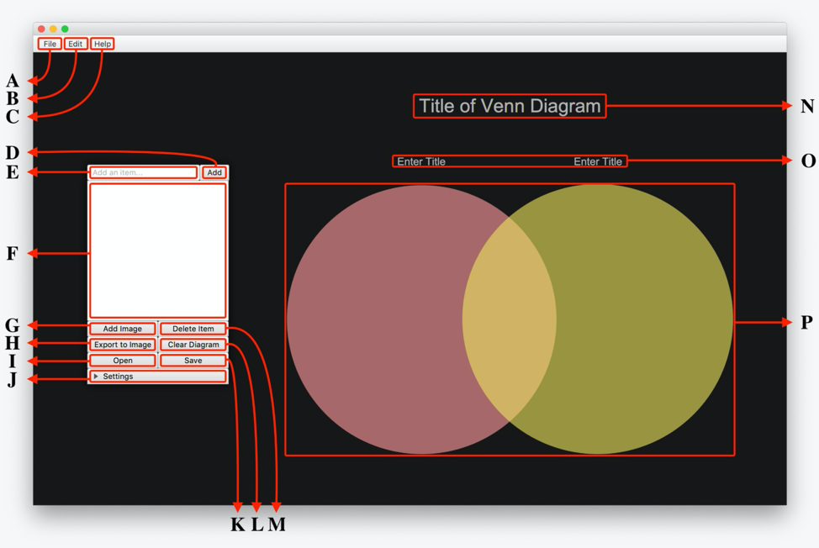

# 5. Future Work

Section 1.2 expanded briefly on the future of the Venn Diagram project; this section will provide necessary depth.

**1. Comparison of three sets in a Venn diagram**

In a future release, the Venn Diagram application will have the option to compare three sets (or potentially more) of data rather than just two. This allows even more flexibility for the user, as three or more sets result in many more intersections. The backend set intersection logic will be a challenge to implement however it can be done. This makes room for a much wider set of use cases to be appeased as well.

**2. Adding images and files into a Venn diagram**

In a future release, the Venn diagram will be able to support comparison of images and files, in addition to the comparison of text that it is capable of now. This also provides more flexibility to the user and opens up wider use cases.

**3. Saving and loading Venn diagrams (Version 1, Implemented)**

In a future release, the user will be able to save Venn Diagram states to a file and open it again later for further editing. This removes the need of keeping the application open to continue working with the Venn Diagram later on.

**4. Creating a login system, with users**

In a future release, users will be able to create their own accounts (with usernames and passwords). Accounts will have Venn Diagrams that the user made associated with them.